# Phase 4 – Process Automation (Admin) — Step-by-step Implementation Guide

# Validation Rules

Validation Rules are used to check conditions before saving a record.

They help in maintaining data quality and enforce business rules.

Example: Require Template field if Task Status is 'Submitted'.

Example: Feedback comments must be filled if Feedback_Submitted = True.

Error messages should be clear and placed on the right field.  
  
  
**Why:** Prevent users from saving incomplete records.

How to add:

1. Setup → Object Manager → Task → **Validation Rules** → **New**.
2. Name it Require_Template_On_Submit.
3. Paste this formula:

AND(ISPICKVAL(Status__c, 'Submitted'), ISBLANK(TEXT(Template__c)))

1. Error Message: “Please select a Template before submitting.” → set error location to Template field → Save.

Second rule (require comments when feedback submitted):

AND(Feedback_Submitted__c = TRUE, ISBLANK(Feedback_Comments__c))

Error message: “Please enter feedback comments before submitting feedback.”

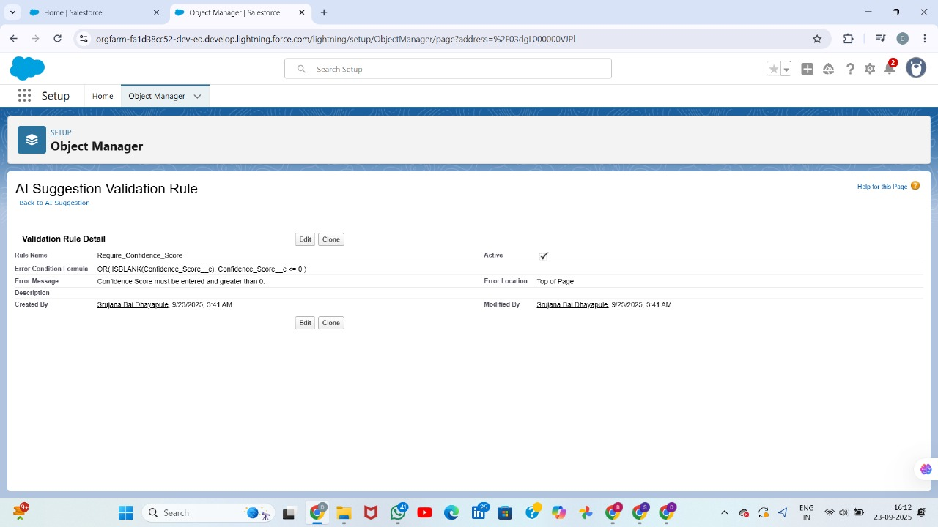

# Workflow Rules

Workflow Rules are older automation tools, mostly replaced by Flow.

They can perform simple actions like Field Update, Email Alert, Task Creation, Outbound Message.

They run automatically when record criteria are met.

Example: When Feedback_Submitted = True → Send Email to Task Owner and update Status.  
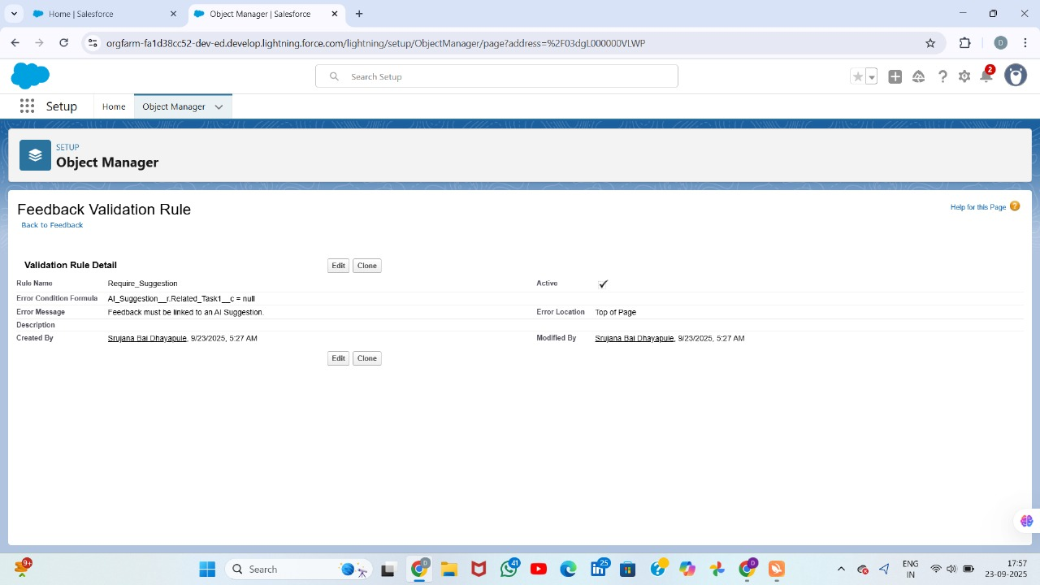

**Define Rule Criteria**

1. **Rule Name:** Give a meaningful name (e.g., Feedback Submission Alert).
2. **Evaluation Criteria:** Choose when to evaluate the rule:
   * **Created** — Trigger only when a record is created.
   * **Created, and every time it’s edited** — Trigger on creation and edits.
   * **Created, and any time it’s edited to meet criteria** — Trigger only when record changes from not meeting to meeting criteria.
3. **Rule Criteria:** Set conditions that trigger the workflow.  
   Example:
   * Field: Feedback_Submitted__c
   * Operator: equals
   * Value: True

# 

**Add Workflow Actions**

After defining criteria, choose **Immediate Workflow Actions**:

**Types of actions:**

1. **New Email Alert** – Send email when criteria are met.
2. **New Field Update** – Automatically update a field.
3. **New Task** – Create a task for a user.
4. **New Outbound Message** – Send data to external system.

**Example:**

* Action: Email Alert to Manager
* Recipient: Manager of record owner
* Email Template: Feedback Submitted

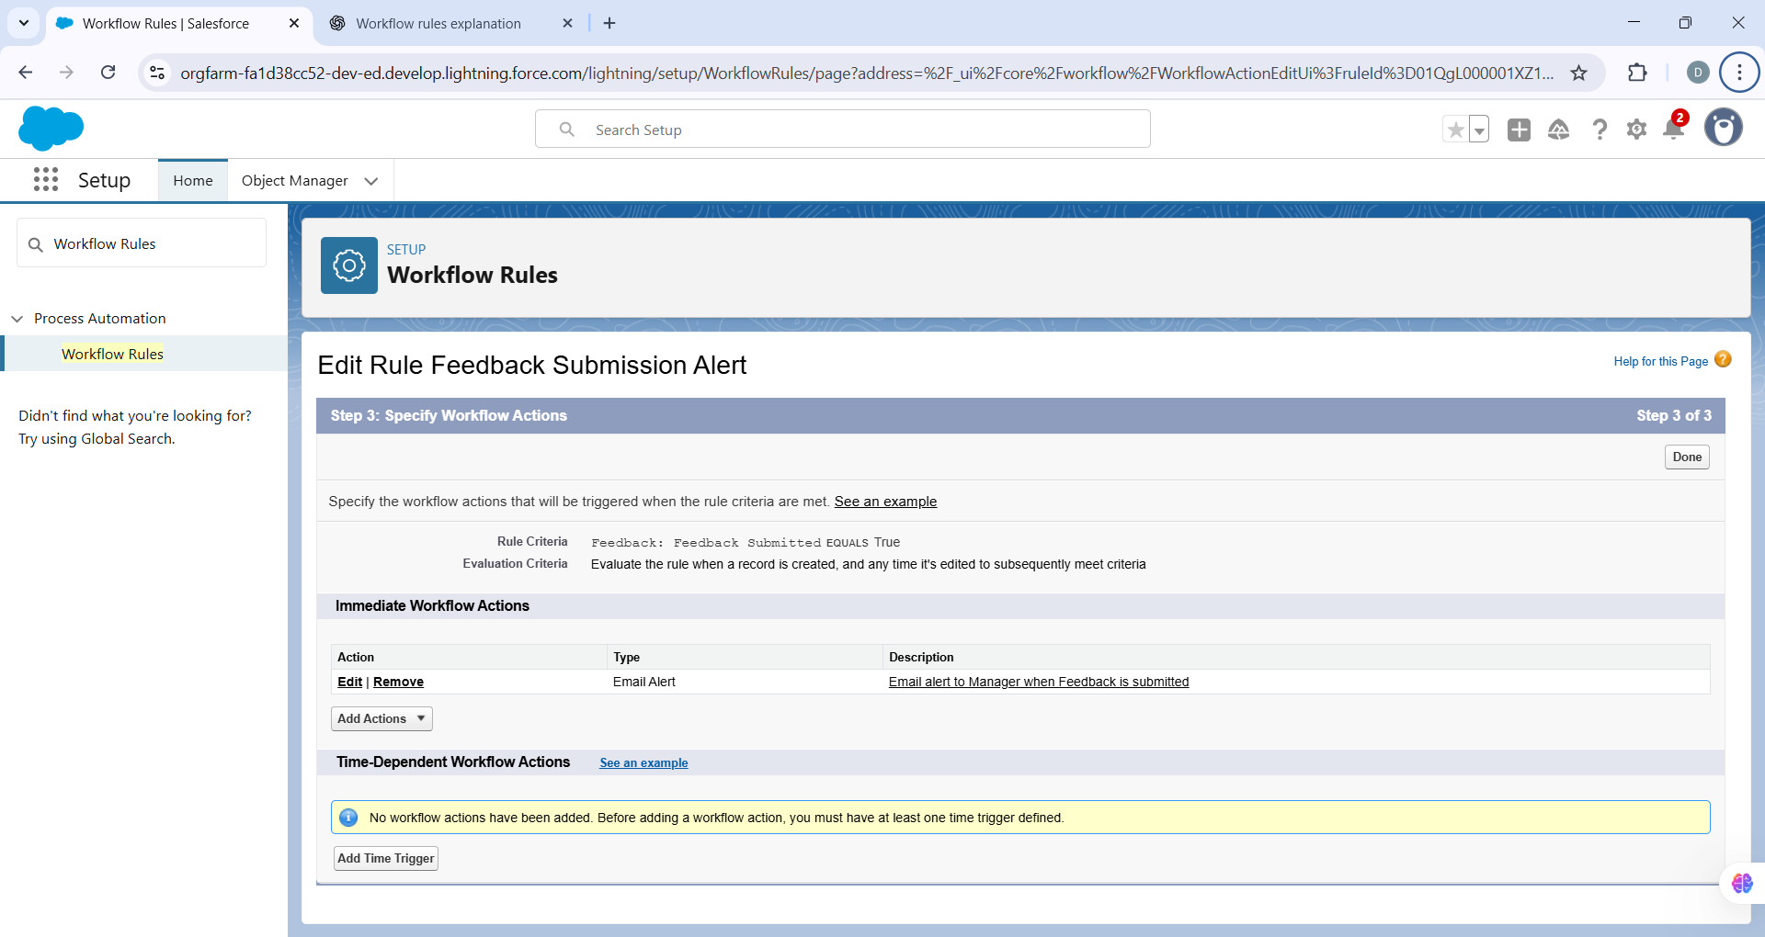

# Process Builder

Process Builder is also a point-and-click automation tool.

It is more advanced than Workflow but still considered legacy compared to Flow.

Can update or create records, call Flows, post to Chatter, or submit for approval.

Example: When Task Priority = High, call a Flow to assign follow-up work.

Now Salesforce recommends using Flow instead of Process Builder.  
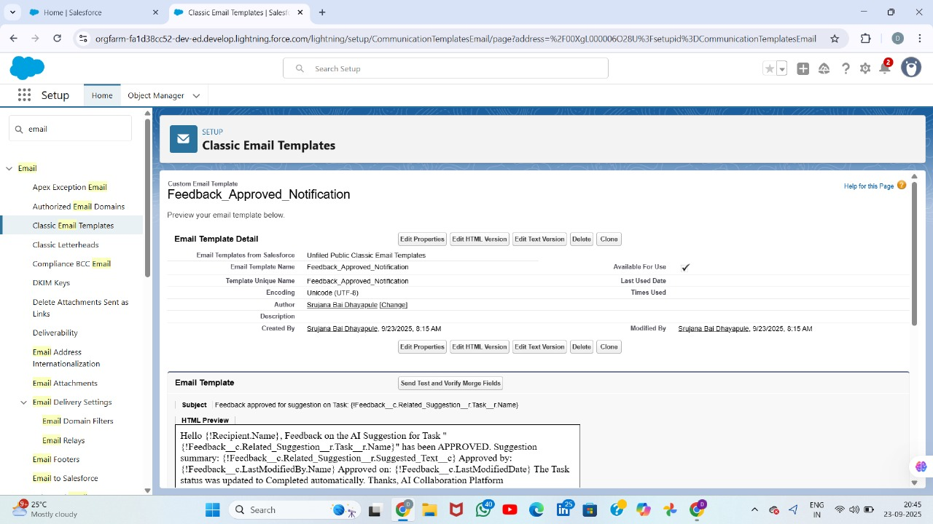  
  
**Step-by-Step: Create a Simple Process Builder**

We’ll create a **Process that updates Task Status when Feedback is approved**.

**Step 1 — Open Process Builder**

1. Salesforce → Click **⚙️ Gear** → **Setup**.
2. Quick Find → Type **Process Builder** → Click **Process Builder**.
3. Click **New** → Enter:
   * **Process Name:** Update Task Status on Feedback Approval
   * **API Name:** Update_Task_Status_Feedback
   * **Description:** Updates Task.Status__c to “Feedback Approved” when feedback is approved.
   * **The process starts when:** A record changes → Click **Save**.

**Step 2 — Choose the Object**

1. Click **+ Add Object** → Choose **Task** (or Feedback object if Feedback is separate).
2. Start the process **when a record is created or edited** → Click **Save**.

**Step 3 — Define Criteria**

1. Click **+ Add Criteria** → Enter:
   * **Criteria Name:** Feedback Approved Check
   * **Criteria for Executing Actions:** Conditions are met
2. Add Condition:
   * Field: Feedback_Approved__c
   * Operator: Equals
   * Type: Boolean
   * Value: True
3. Conditions: All conditions must be met (AND) → Save.

**Step 4 — Add Immediate Actions**

1. Click **+ Add Action** under Immediate Actions.
2. Action Type: **Update Records** → Name: Update Task Status.
3. Select **Record related to the Task** (or Task itself).
4. Set field values:
   * Field: Status__c
   * Type: Picklist
   * Value: Feedback Approved
5. Click **Save**.

**Step 5 — Activate the Process**

1. Click **Activate** → Confirm activation.
2. Test by updating a record where Feedback_Approved__c = True → Task.Status__c should change automatically.

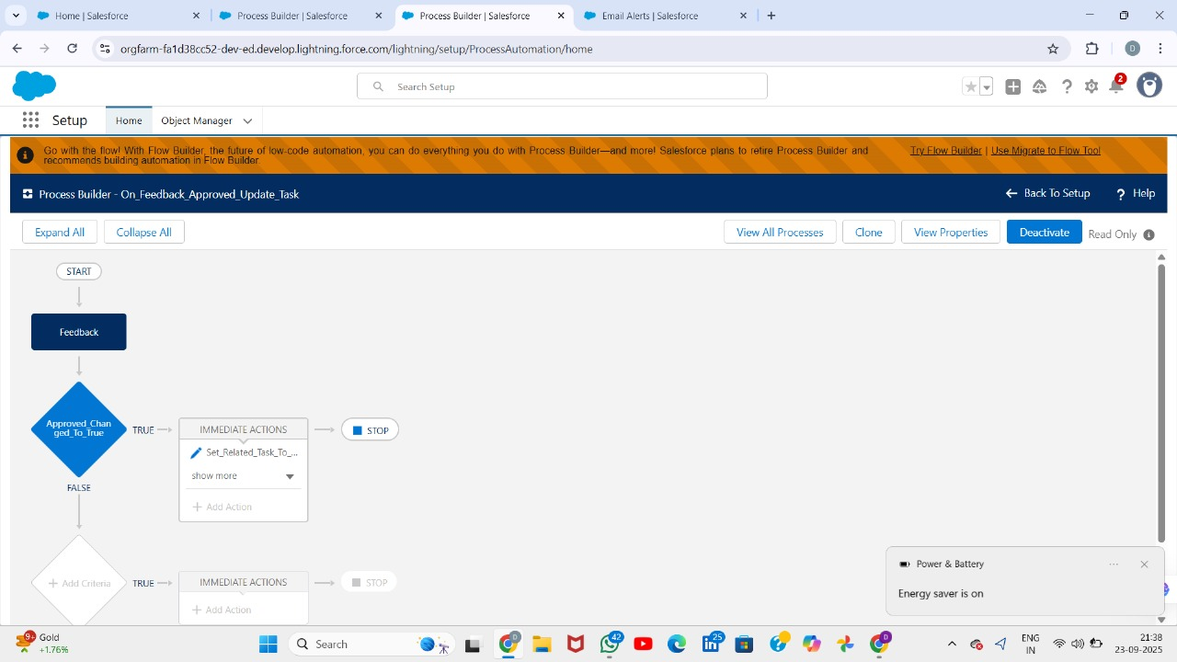

# Approval Process

Approval Process is used when a record needs formal review or manager approval.

It has entry criteria, approvers, and actions for approval or rejection.

During approval, the record can be locked, updated, or trigger emails.

Example: When Feedback is submitted, send it for approval. If approved → update Task Status to 'Feedback Approved'.

Rejection can also send an alert and update status to 'Rejected'.  
**Create fields on Feedback__c**

Go to **Object Manager** → **Feedback** → **Fields & Relationships**.

**(A) Create Feedback_Submitted__c (Checkbox)**

1. Click **New Field** → choose **Checkbox** → **Next**.
2. **Field Label**: Feedback Submitted  
   (API will be Feedback_Submitted__c)
3. **Default Value**: Unchecked.
4. Add help text (optional): *“Check to submit Feedback for approval.”*
5. Click **Next** → set visibility for needed profiles → **Next** → add to Page Layout → **Save**.

**(B) Create Feedback_Approved__c (Checkbox)**

1. Again **New Field** → **Checkbox**.
2. **Label**: Feedback Approved  
   (API = Feedback_Approved__c)
3. Default: Unchecked.
4. Save (same steps as above).

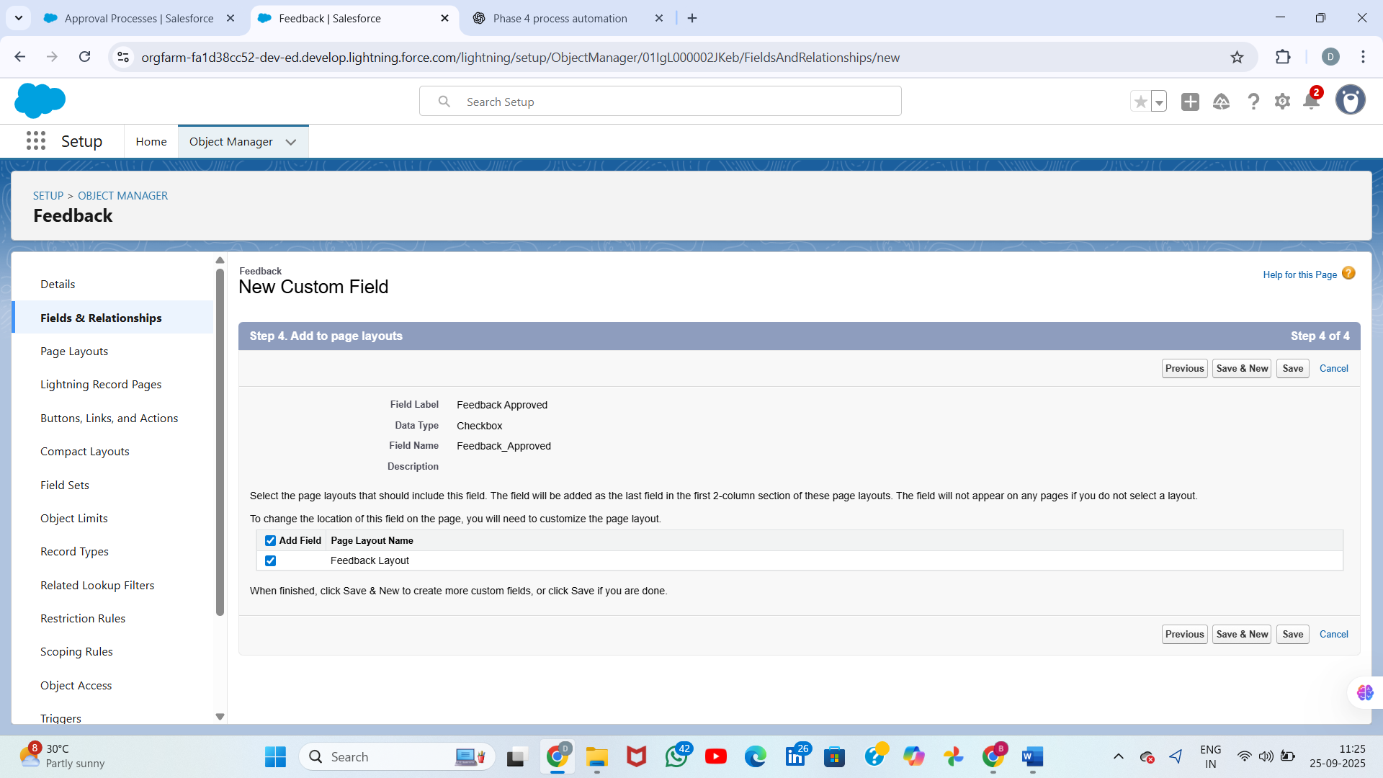

**C. (Option 1) Create Feedback_Status__c as a Picklist (recommended if you want users to edit/status report)**

1. Fields & Relationships → **New** → choose **Picklist** → **Next**.
2. Field Label: Feedback Status → API Feedback_Status__c.
3. Enter picklist values (each on a new line), for example:
4. Draft
5. Pending
6. Approved
7. Rejected
8. Needs Changes
9. Set **Default Value**: Draft or Pending as you prefer.
10. Next → field-level security → add to page layouts → Save.

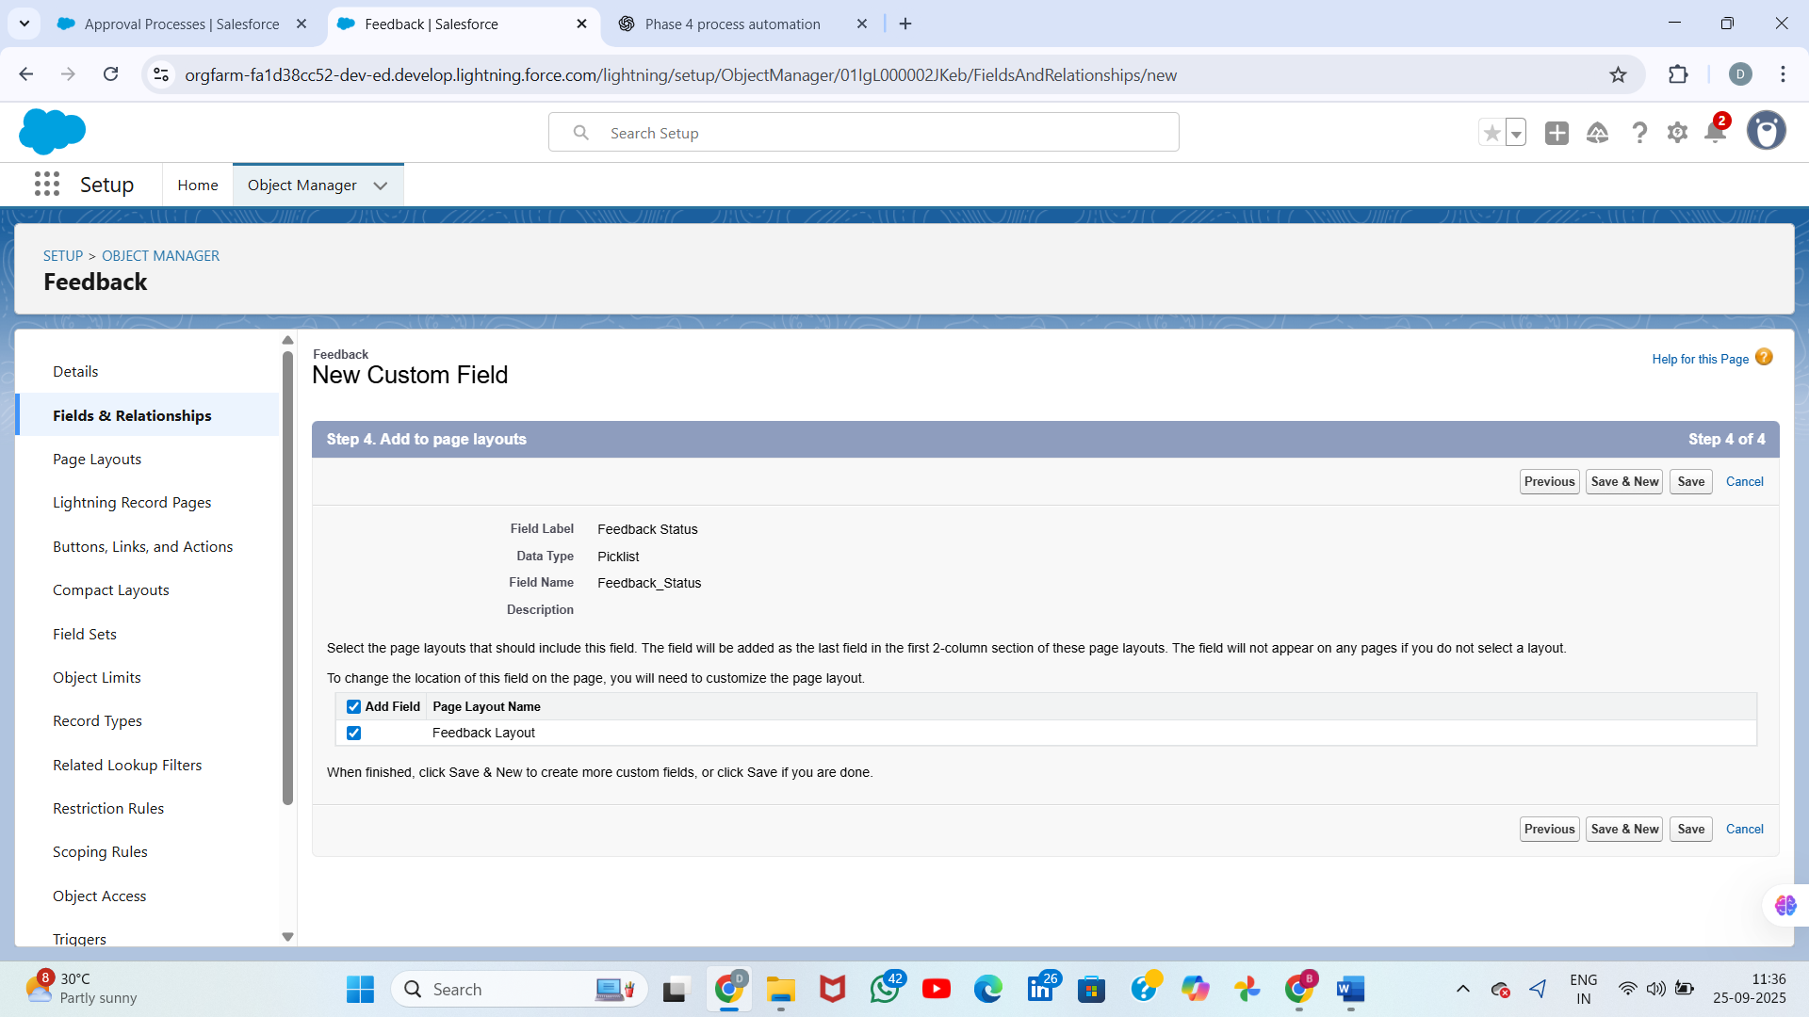

**Add Field Update** (optional) — set Feedback_Status__c = Pending (or set a flag).

**Add Email Alert** to notify the approver. To create the email alert:

* Create an Email Template (Setup → Email → Classic/Lightning Email Templates).
* Then Setup → Email Alerts → New → select template, recipient = Approver/Owner. Add that Email Alert to **Initial Submission Actions**.

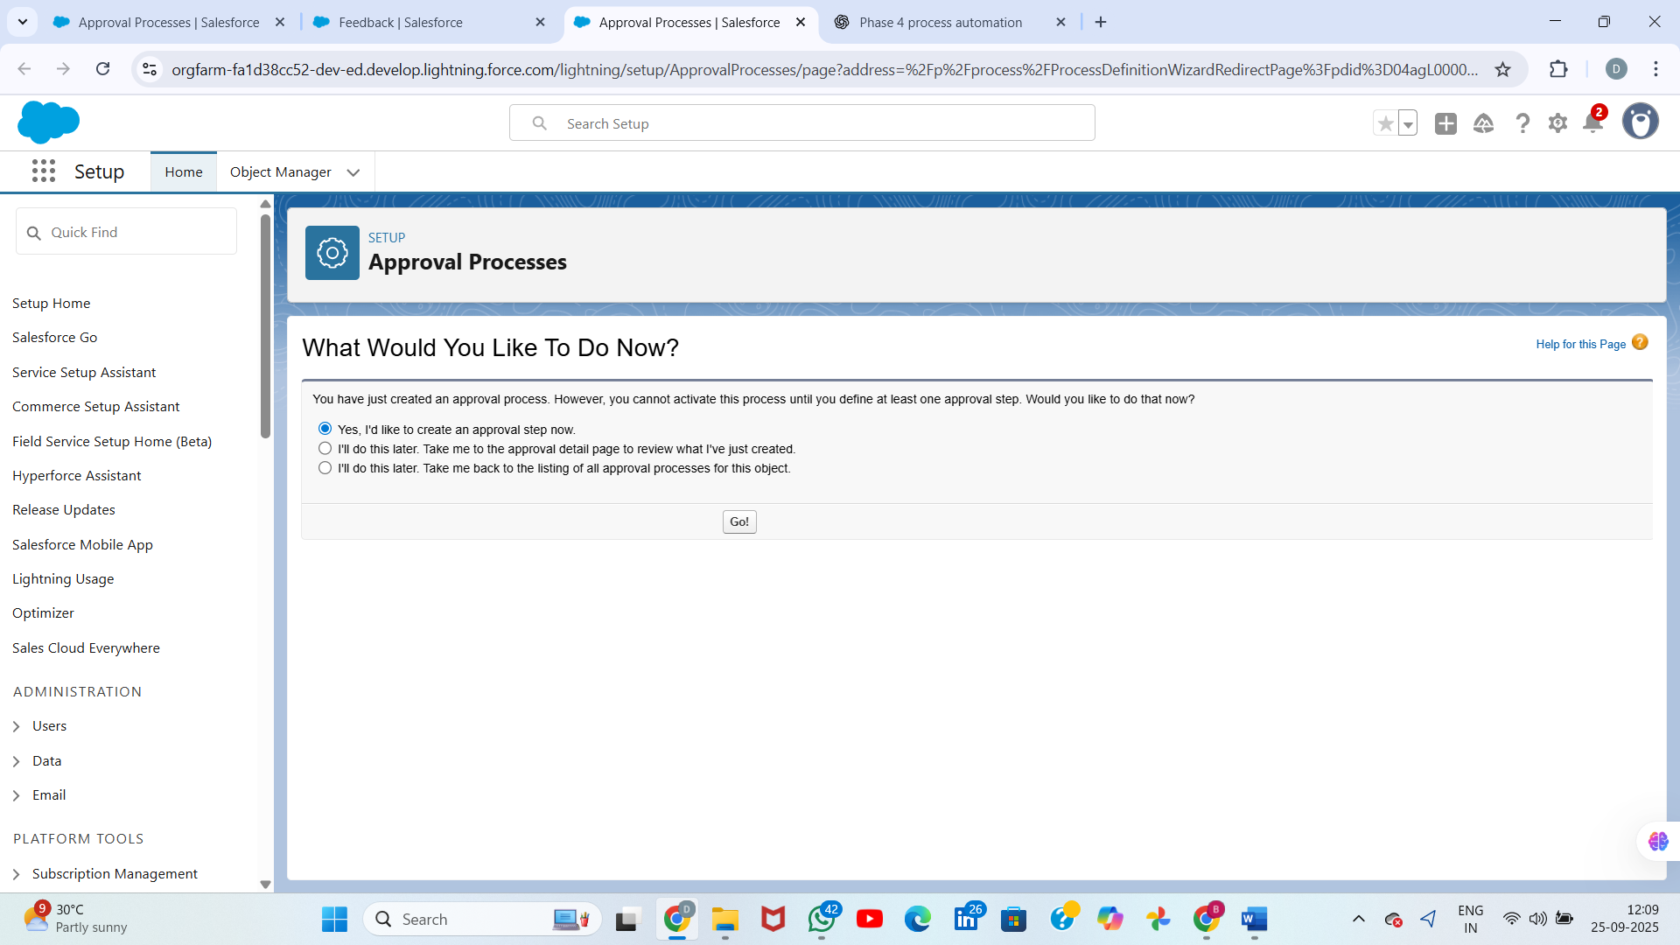

# Flow Builder

Flow Builder is the main automation tool in Salesforce.

It supports different types: Screen Flow, Record-Triggered Flow, Scheduled Flow, Autolaunched Flow.

Screen Flow: User-guided form, e.g., create a Task with Template selection.

Record-Triggered Flow: Runs automatically when a record is created or updated, e.g., after feedback submission.

Scheduled Flow: Runs at specific times, e.g., daily reminders for pending approvals.

Autolaunched Flow: Reusable logic with no UI, called from other Flows or Apex.

Flows are powerful because they support conditions, branching, loops, and calling subflows.

# Email Alerts

Email Alerts send automatic mails based on templates.

They are triggered from Workflow, Process Builder, or Flow.

Templates can use merge fields for personalization.

Example: Send email to Task Owner when Feedback_Submitted = True.

Best practice: Always test templates with sample data.  
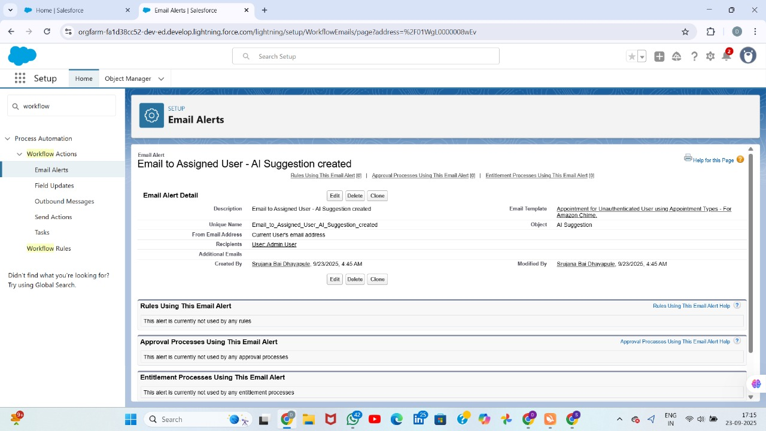  
  
**Email Templates & Email Alerts (notify people)**

1. Setup → Email Templates → **New** (Lightning or Classic).
   * Name: Feedback Submitted - Task
   * Subject: Feedback submitted for Task {!Task.Subject}
   * Body example:

Hi {!Task.OwnerName},

Feedback was submitted for Task: {!Task.Subject}.

Comments:

{!Feedback__c.Feedback_Comments__c}

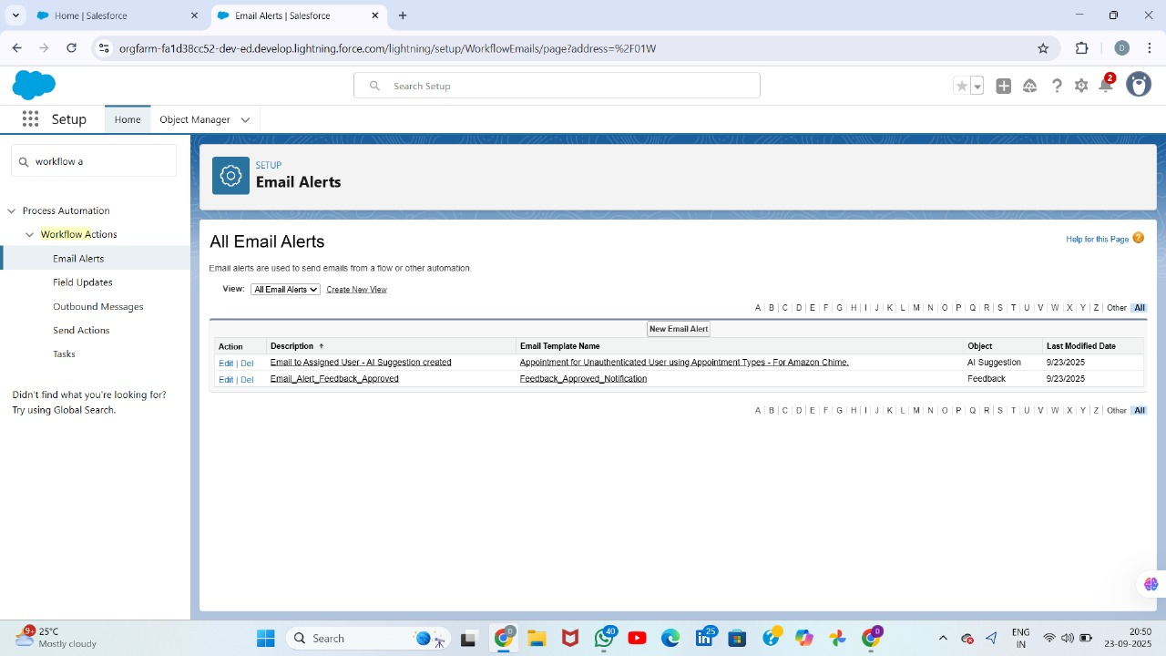

# Field Updates

Field Updates are used to automatically change field values on records.

They can be triggered by Workflow, Process Builder, or Flow.

Example: If Feedback Approved = True → set Task Status = 'Completed'.

Best to use Before-Save Record-Triggered Flows for faster updates.

Helps maintain consistency without manual effort.

**Step 1 — Create an autolaunched flow (the reusable subflow)**

**Clicks**

1. Click the **⚙️ (gear)** → **Setup**.
2. Quick Find → type **Flows** → click **Flows**.
3. Click **New Flow**.
4. Select **Autolaunched Flow (No Trigger)** → **Create**.

**Why autolaunched?**  
Autolaunched flows can be called from record-triggered flows, buttons, or Next Best Action — perfect for re-use. 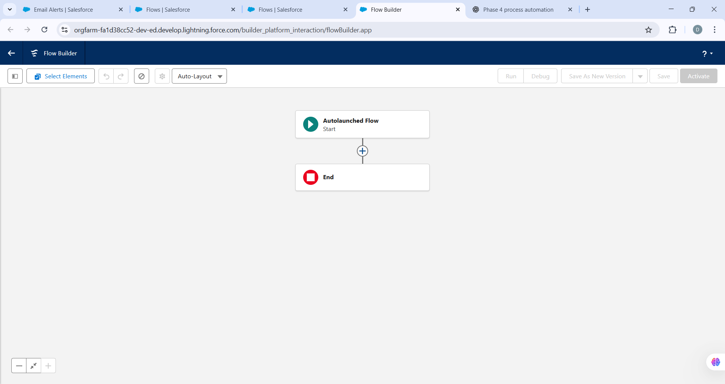

**reate input/output variables the flow needs**

In the Flow canvas, create these **variables** (Resources → New Resource):

1. **varTaskId**
   * Resource Type: Variable
   * API Name: varTaskId
   * Data Type: Text
   * Check **Available for input** (so other flows can pass the Task Id)
2. **varOwnerId** (optional)
   * API Name: varOwnerId
   * Type: Text
   * Available for input
   * Use: If provided, we will reassign task/follow-up to this owner; otherwise keep existing owner.
3. **varFollowUpDays**
   * API Name: varFollowUpDays
   * Type: Number
   * Default Value: 3
   * Available for input
4. **varFollowUpSubject**
   * API Name: varFollowUpSubject
   * Type: Text
   * Default Value: Review feedback
   * Available for input
5. **varNewStatus** (optional)
   * API Name: varNewStatus
   * Type: Text
   * Default Value: Feedback Received (or the picklist value you want)
   * Available for input
6. **varOwnerToUse** (internal)
   * API Name: varOwnerToUse
   * Type: Text
   * Not available for input (we will set it via Assignment)

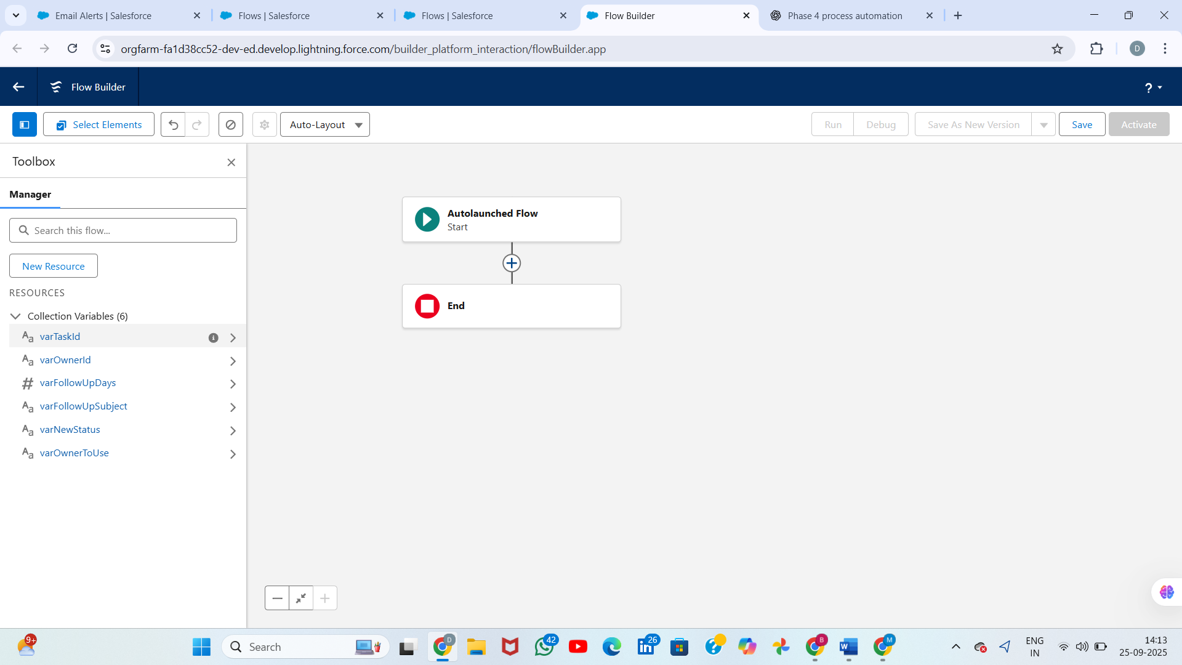

**Step 3 — Decision: was an owner provided? (matches Image 3)**

1. Click **+** after Get_Task → **Logic → Decision**.
2. Label: **Owner Provided?**
3. Create an Outcome (named **Provided**) with condition:
   * **{!varOwnerId} Is Null = False**
   * (Meaning: the caller passed varOwnerId.)
4. Use the default outcome as the **Use Existing** branch.

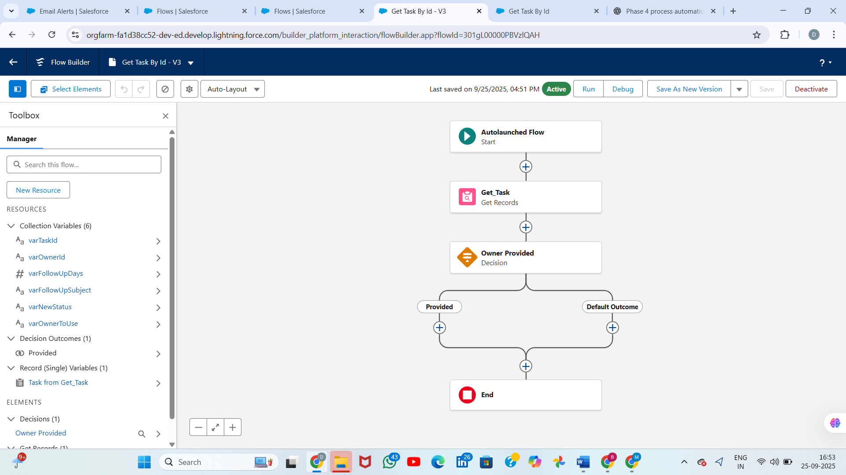  
**Step 4 — Assign varOwnerToUse (matches Image 4)**

You have two branches from the Decision. For each branch add an **Assignment** that sets varOwnerToUse:

* For **Provided** outcome:
  + Assignment: **Set varOwnerToUse = {!varOwnerId}**
  + 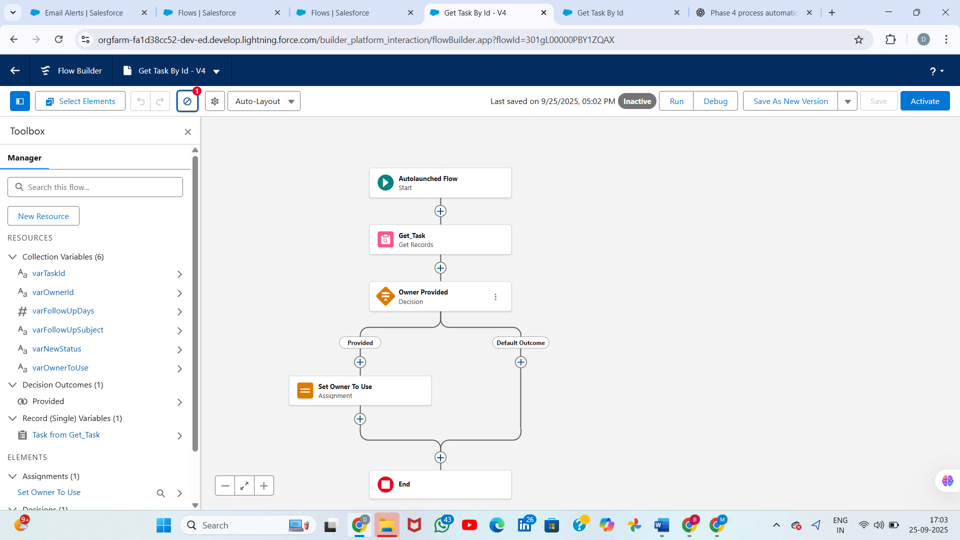
* For **Use Existing** (default) outcome:
  + Assignment: **Set varOwnerToUse = {!Get_Task.OwnerId}**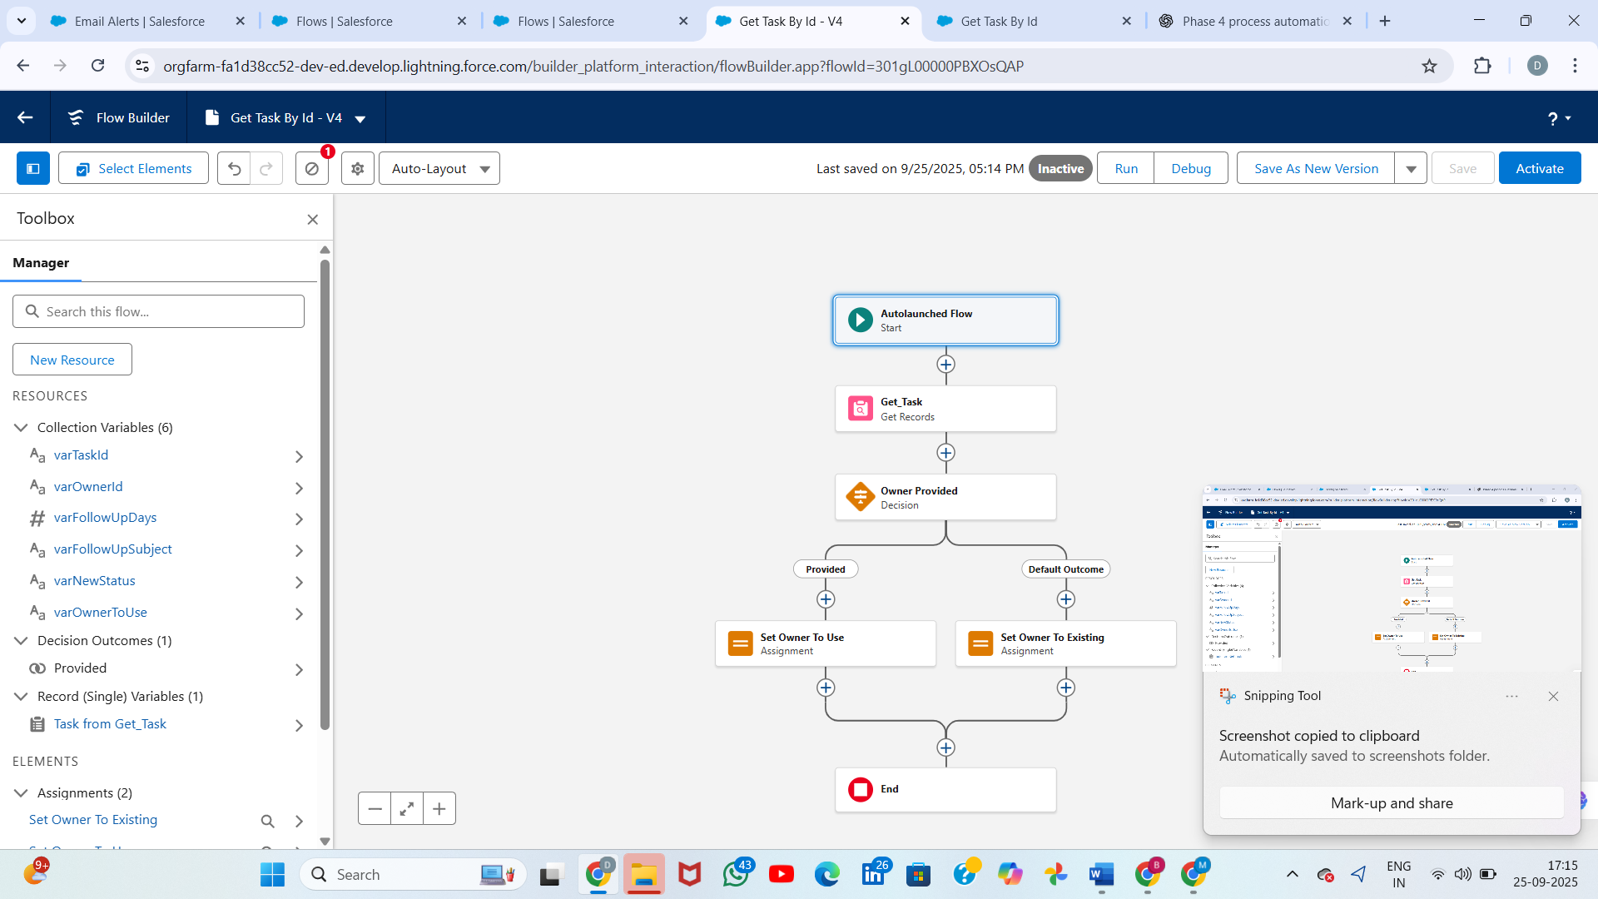

Connect each Decision outcome to its Assignment. Both assignments should then continue to the next step (they converge).

# Tasks

Tasks are standard Salesforce activities assigned to users.

Automation can create tasks automatically to remind or assign work.

Example: After Feedback is submitted, create a Task 'Review feedback' assigned to the owner.

Important fields: Subject, Due Date, Priority, and Owner.

Helps ensure follow-ups are not missed.  
  
**Step A — Auto-Create a Task When Feedback is Submitted**

**Use case:** If a student (or user) submits Feedback on an AI Suggestion, automatically create a Task for the Assigned User to review it.

**Steps:**

1. Setup → Quick Find → **Flows** → **New Flow**.
2. Choose **Record-Triggered Flow** → **Feedback__c** object.
3. Trigger: When a record is **Created**.
4. Condition: Approved__c = TRUE.
5. After Save → Done.
6. Add **Create Records** → Object = Task__c (your custom Task).
7. Set fields:
   * **Task Name** = "Review Approved Feedback"
   * **Description** = "Feedback {!$Record.Id} approved. Please verify."
   * **Status** = New
   * **Assigned_User__c** = Supervisor or {!$Record.CreatedById} (depending on your process)
   * **Related_AI_Suggestion__c** = {!$Record.Related_Suggestion__c}
8. Save → Activate.

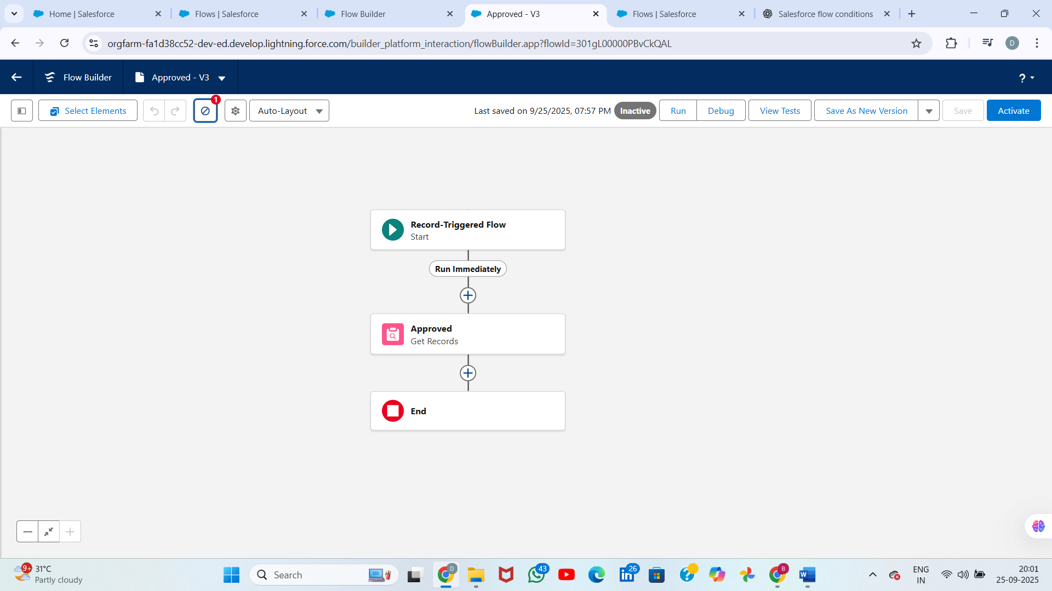

# Custom Notifications

Custom Notifications send push alerts in Salesforce app or desktop.

Admin defines Notification Type, and Flows can send notifications instantly.

They appear in the notification bell icon or mobile app.

Example: Send a notification to Task Owner when feedback is submitted.

Good for real-time alerts without relying only on email.  
**A — Create the Custom Notification Type**

1. Setup → Quick Find → **Notification Builder** → **Custom Notifications**.
2. Click **New**.
3. Fill:
   * **Notification Name:** Supervisor Alert
   * **Developer Name:** auto-populated
   * **Supported Channels:** check **Desktop** and **Mobile** (optional)
4. Save.

Result: a custom notification type Supervisor Alert is available to use inside Flows.

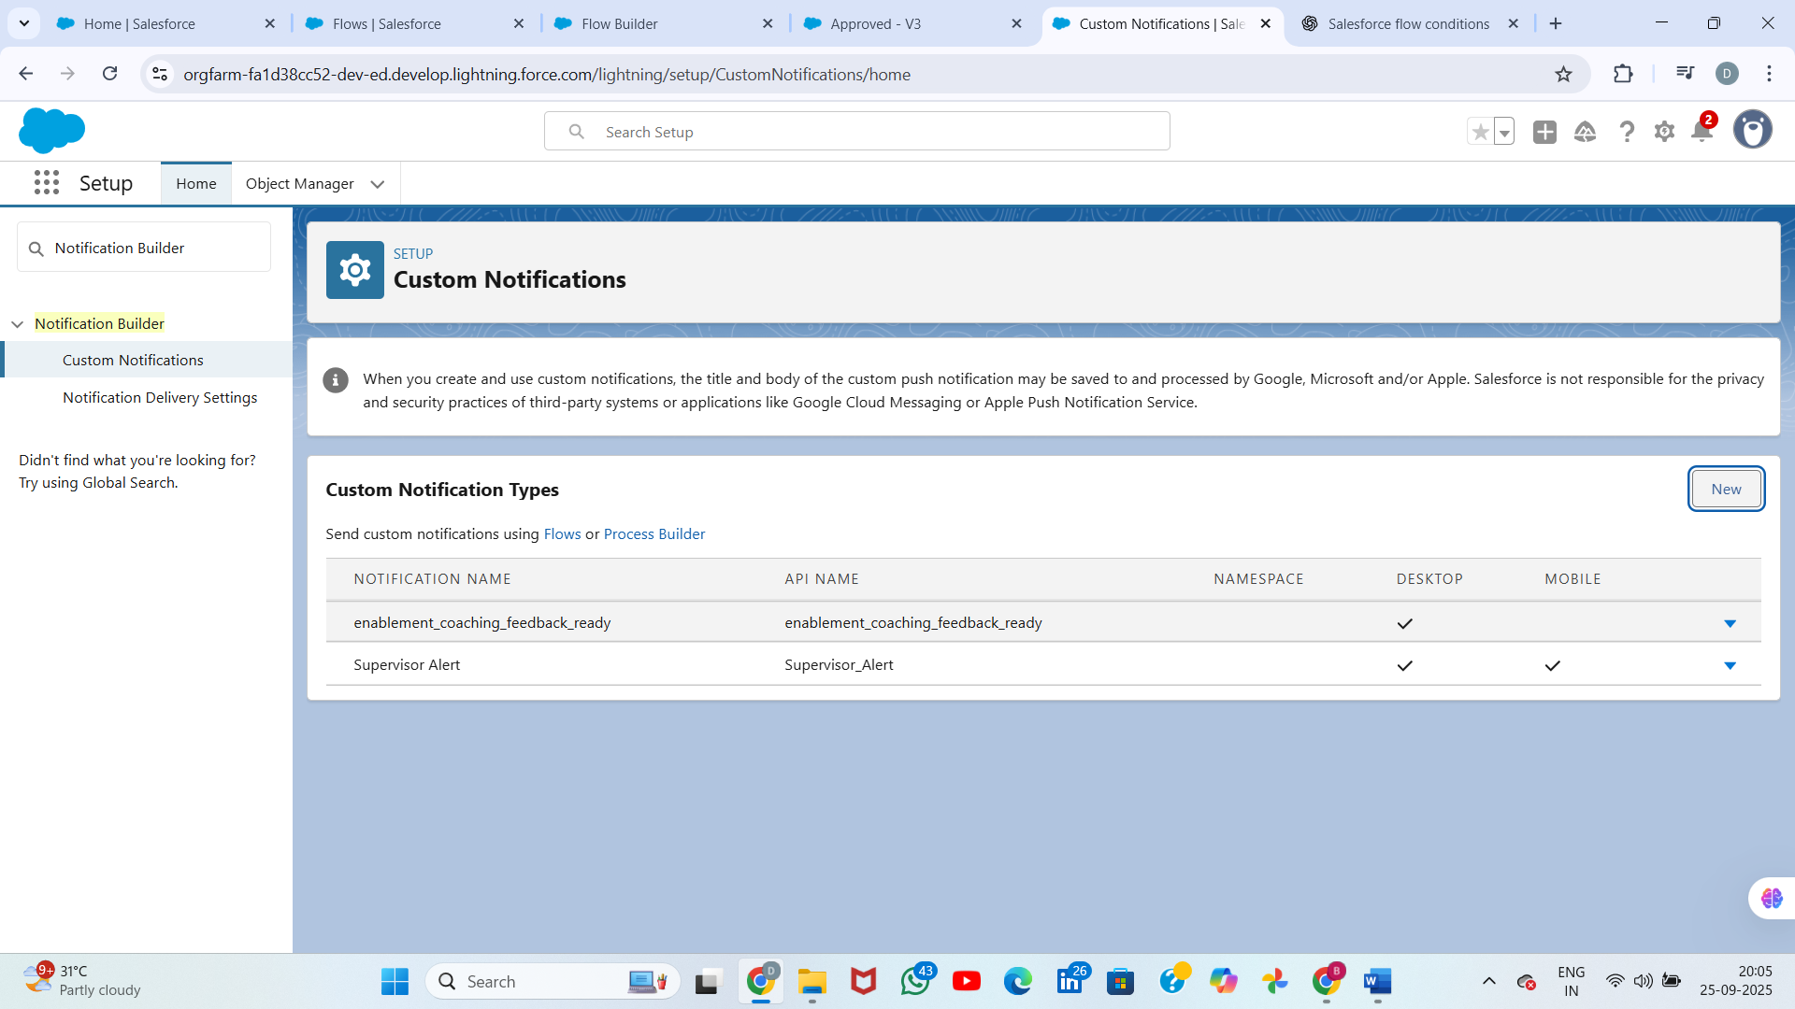

**B — Build a Record-Triggered Flow that Creates a Task + Sends Custom Notification**

**Use case:** When an **AI Suggestion** is created or updated and **Confidence Score < 70%**, automatically create a Task for the Supervisor and send them a Custom Notification.

**1 — Open Flow Builder**

1. Setup → Quick Find → **Flows** → **New Flow**.
2. Choose **Record-Triggered Flow** → Click **Create**.

**2 — Flow Trigger (Start)**

1. **Object:** AI_Suggestion__c (or select your AI Suggestion object).
2. **Trigger:** When **A record is created or updated**.
3. **Condition Requirements:**
   * Condition: Confidence_Score__c < 70 (choose the field and operator)
   * (Optional) Add AND Status__c != "Flagged" to avoid repeated triggers.
4. **When to Run the Flow:** Run the flow **After the record is saved** (we need the record Id available to create related records).
5. Click **Done**.

